LAB 2

Subject: OSG202

Teacher : Nguyễn Tấn Phúc

Student: Dương Hồng Quân

Student ID: SE170057

**man command**

* **Syntax**

|  |
| --- |
| man [OPTION][SECTION] PAGE… |

* **Funtion**

View the system’s reference manual.

* **Example**

1.View the manual page for the man command.

|  |
| --- |
| man man |

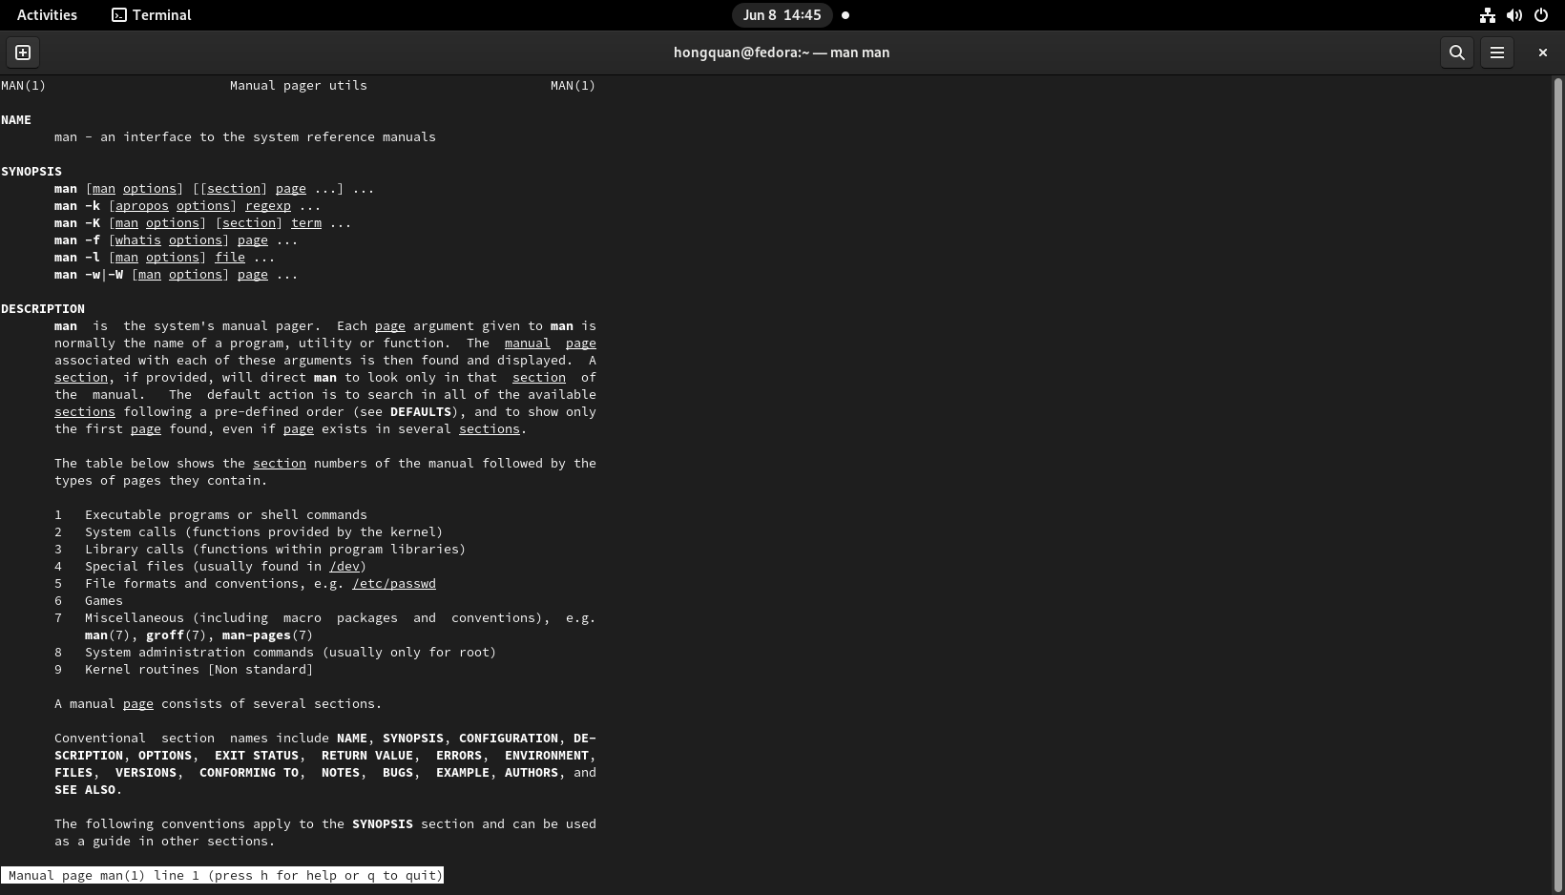

2. Manual pages of the command “printf” are simply returned.

|  |
| --- |
| man printf |

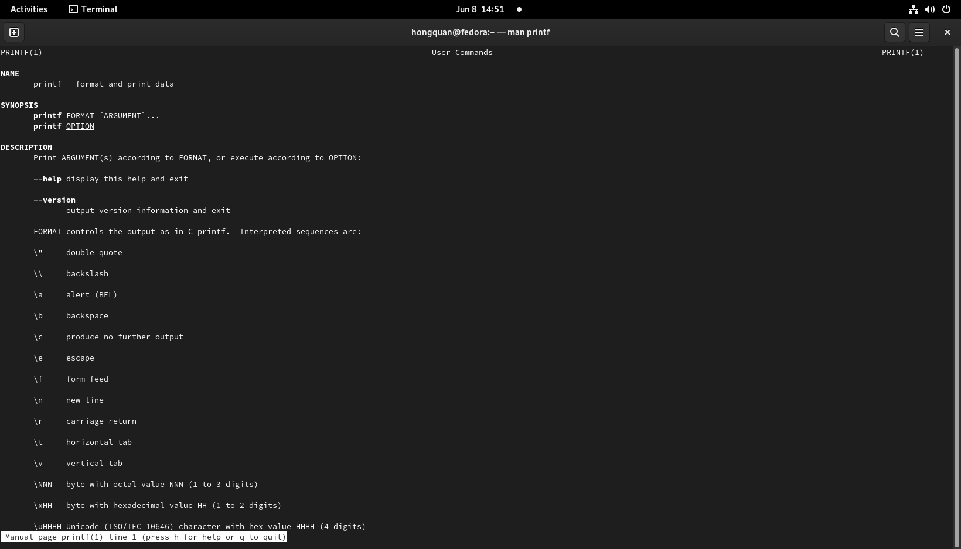

**Sudo command**

* Syntax

|  |
| --- |
| sudo [command] |

* Example:

1. lists the user’s privileges, or checks a specific command

|  |
| --- |
| sudo -l |

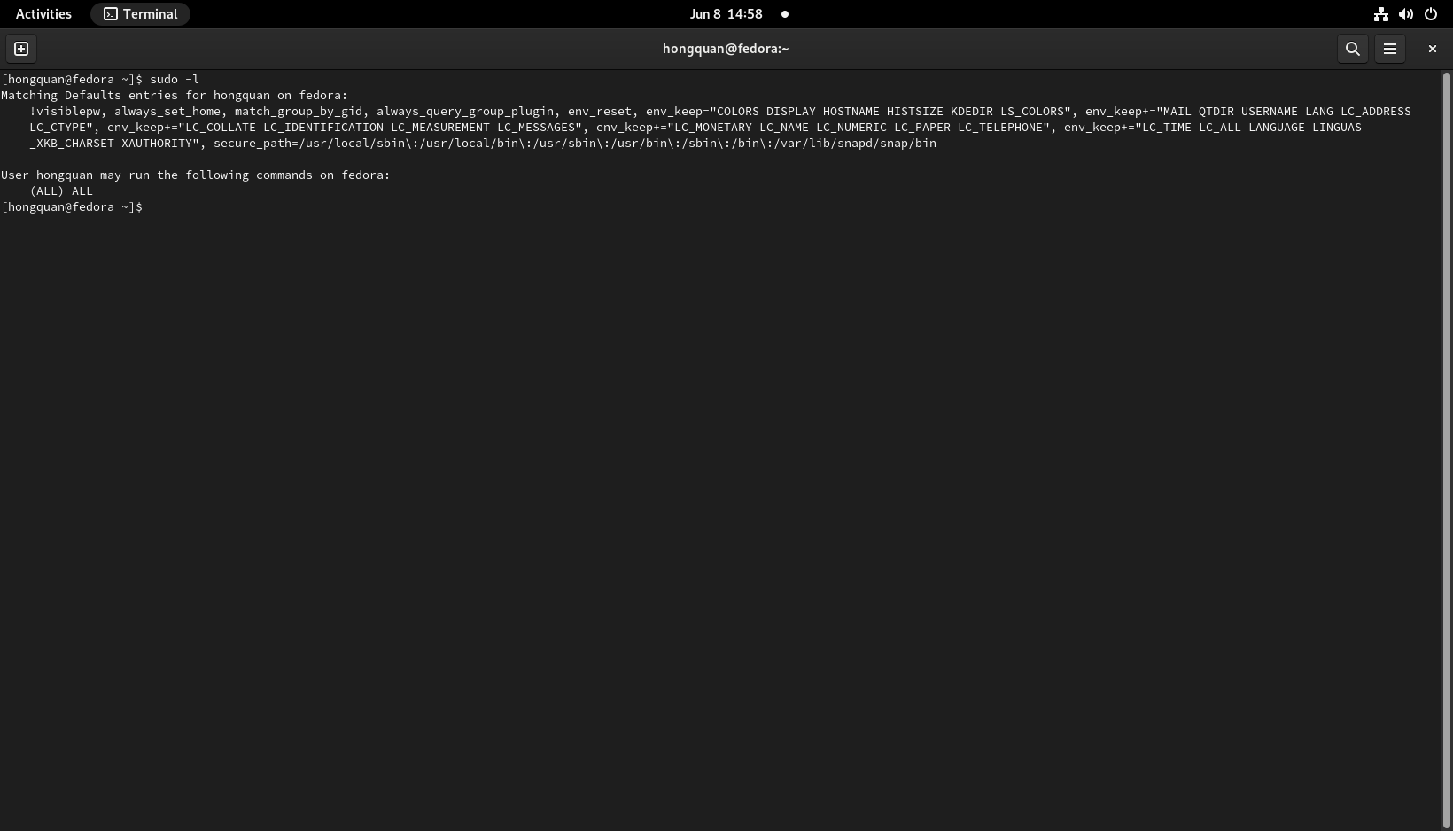

2. displays syntax and command options

|  |
| --- |
| sudo --help |

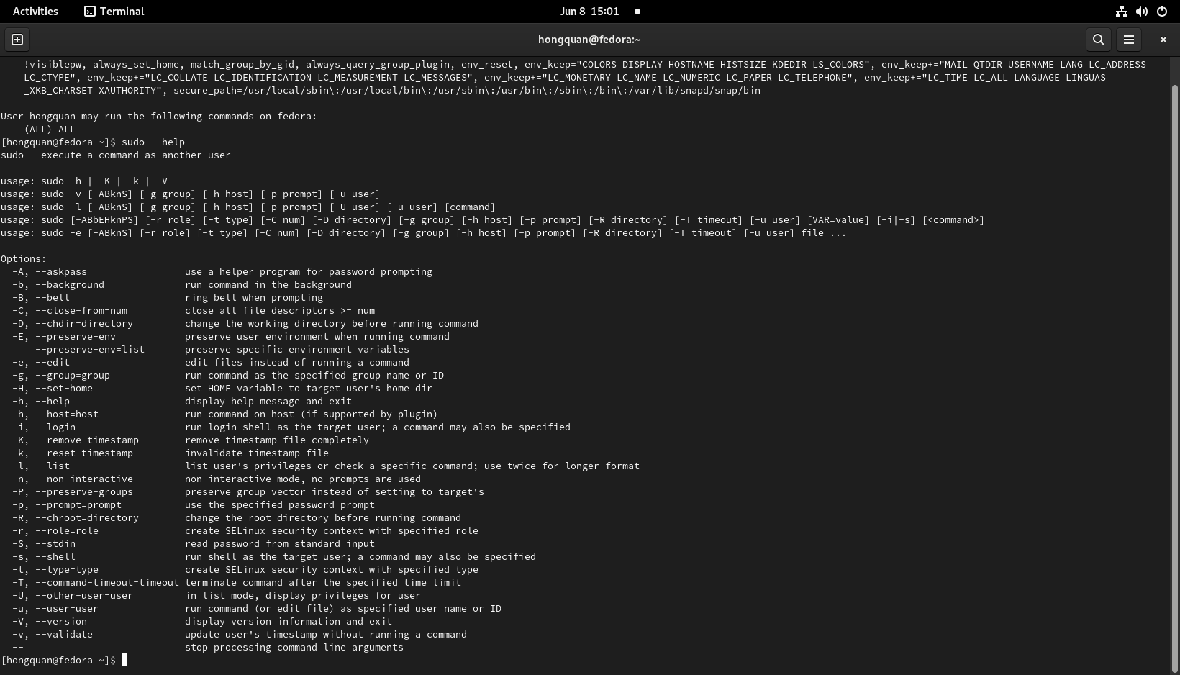

**Chown command**

* **Syntax**

|  |
| --- |
| chown [OPTION]…[OWNER]:[GROUP] FILE… |

|  |
| --- |
| chown [OPTION]…--reference = RFILE FILE… |

* **Funtions**

Change the ownersip of files and directories in a filesystem.

* **Example**

1.Change the owning group of the file thoca.txt to the group named **hongquan**

|  |
| --- |
| chgrp hongquan thoca.txt |

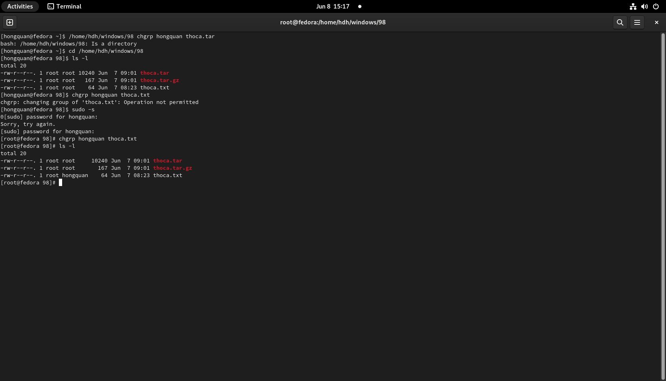

2.Change the root group to the group **hongquan**

|  |
| --- |
| chgrp -hR hongquan unix |

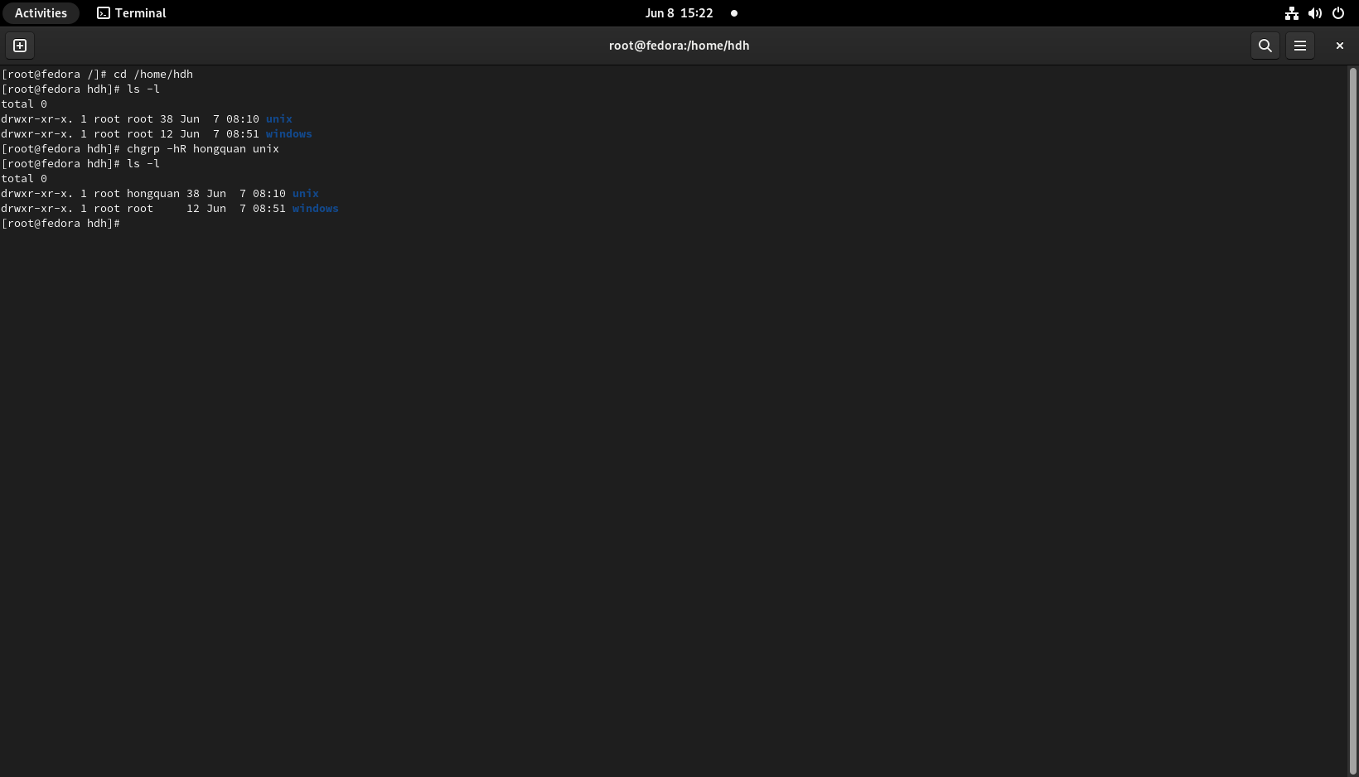

**Date command**

* **Syntax**:

|  |
| --- |
| date [OPTION]…[+FORMAT] |

|  |
| --- |
| Date [-u |--utc | --universal] [MMDDhhmm[[CC|YY][.ss]] |

* **Funtion:**

Print out, or change the value of the system ‘s time and date information

* **Example**:

1**.Print the system date and time**

|  |
| --- |
| date |

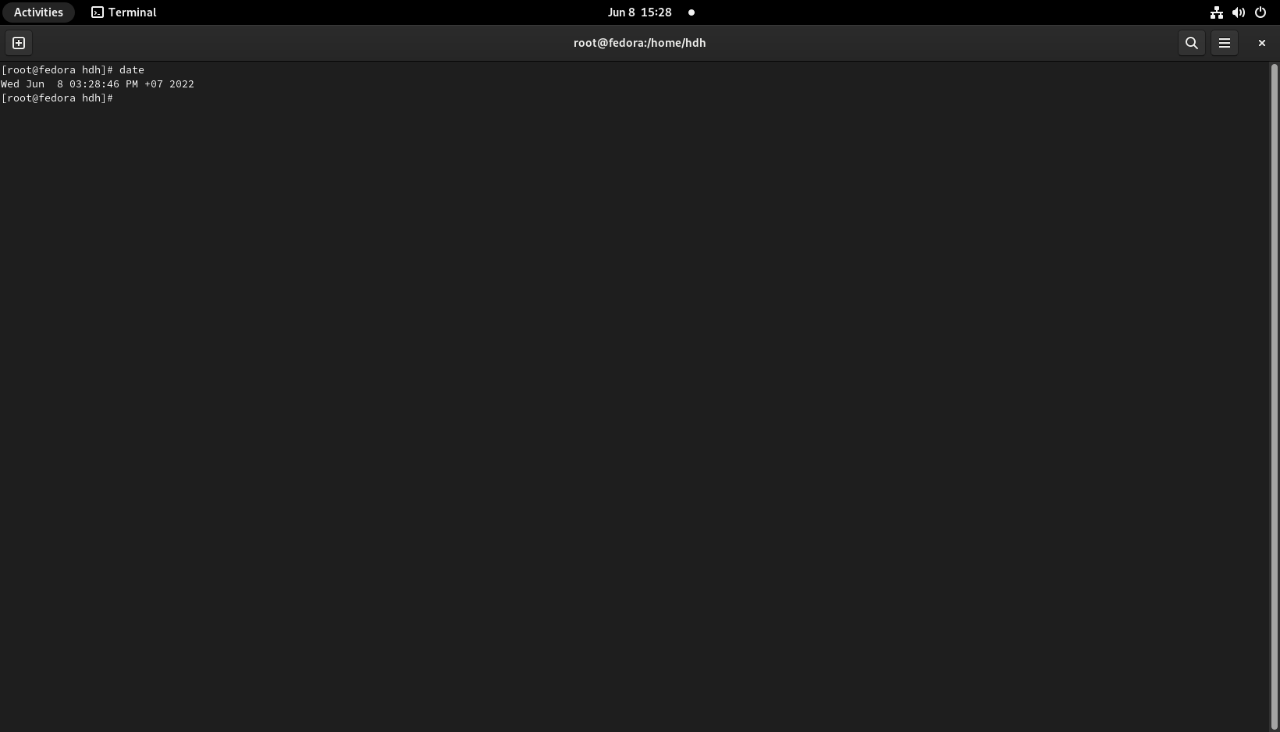

**2**. displays syntax and command options

|  |
| --- |
| date --help |

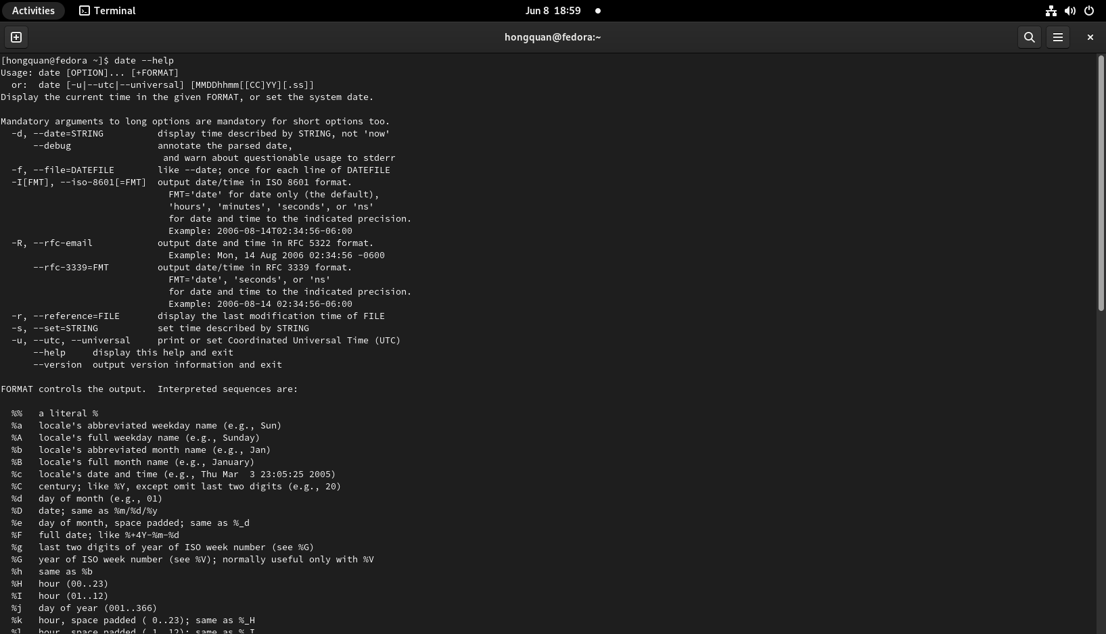

**Grep “thaison” thoca.txt**

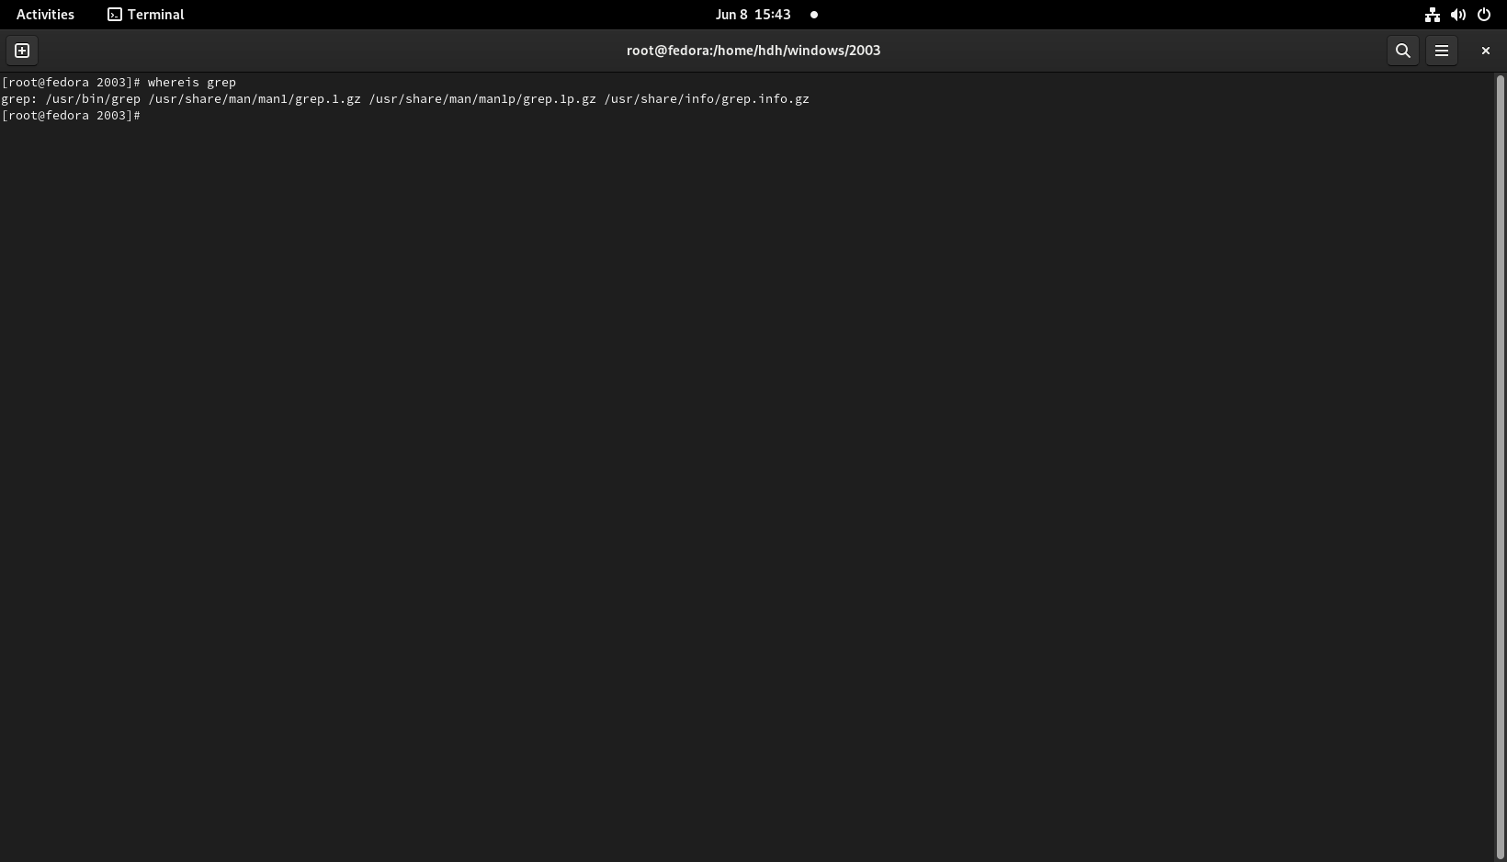

**Explain**:

The grep command is used to print out the line in the text file that matches a specified pattern.

In this context, the file and the pattern are thoca.txt and “thai son”. After entering the grep command , it processed the text in thoca.txt line by line to find the line that have the string “ thai son “ in it.

Finnaly, it printed out the result, which is the line “cong cha nhu nui thai son” with “thai son” in red.

**C files:**

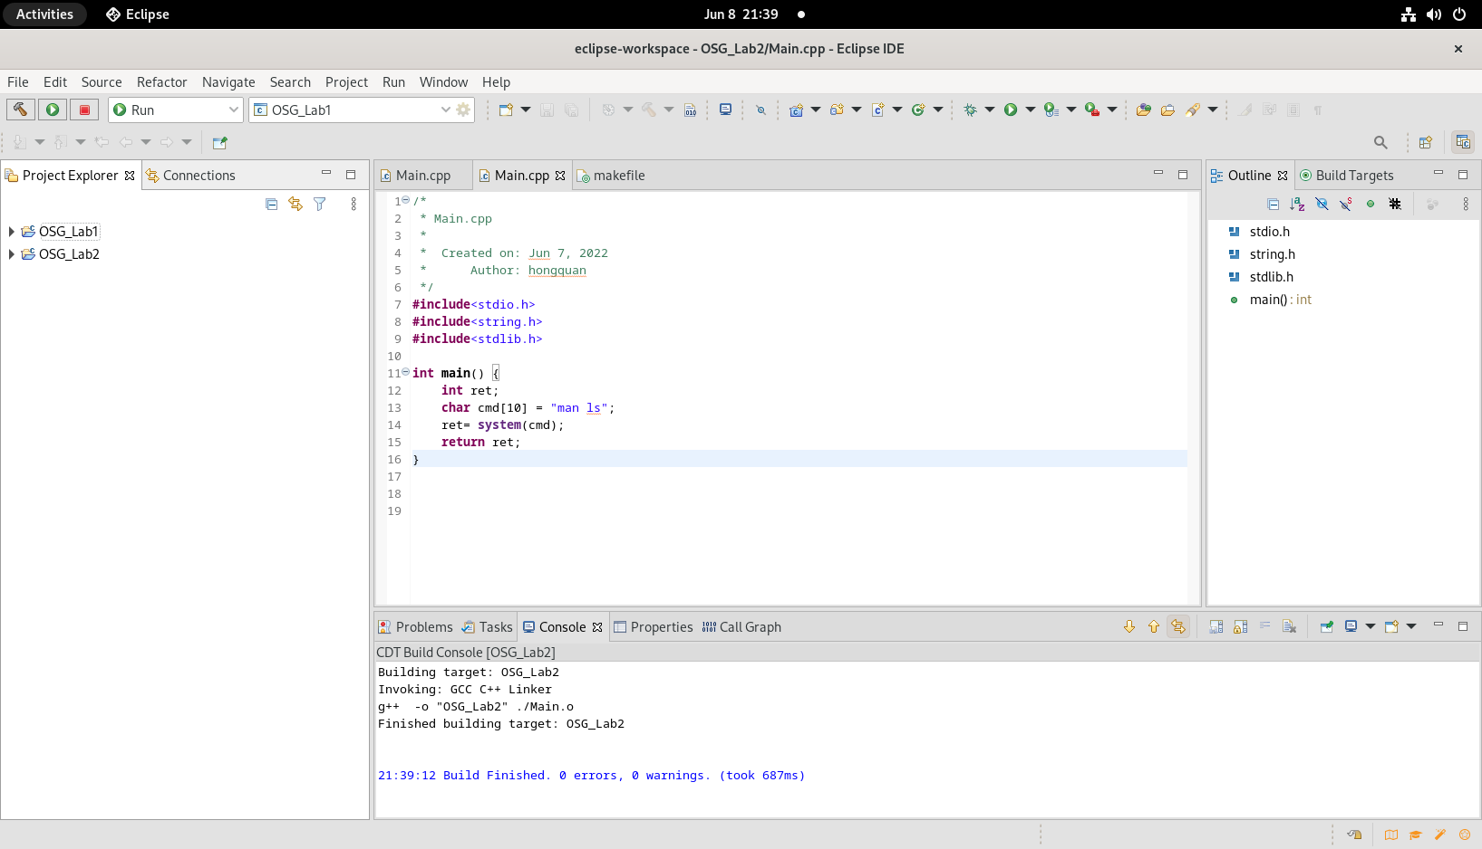

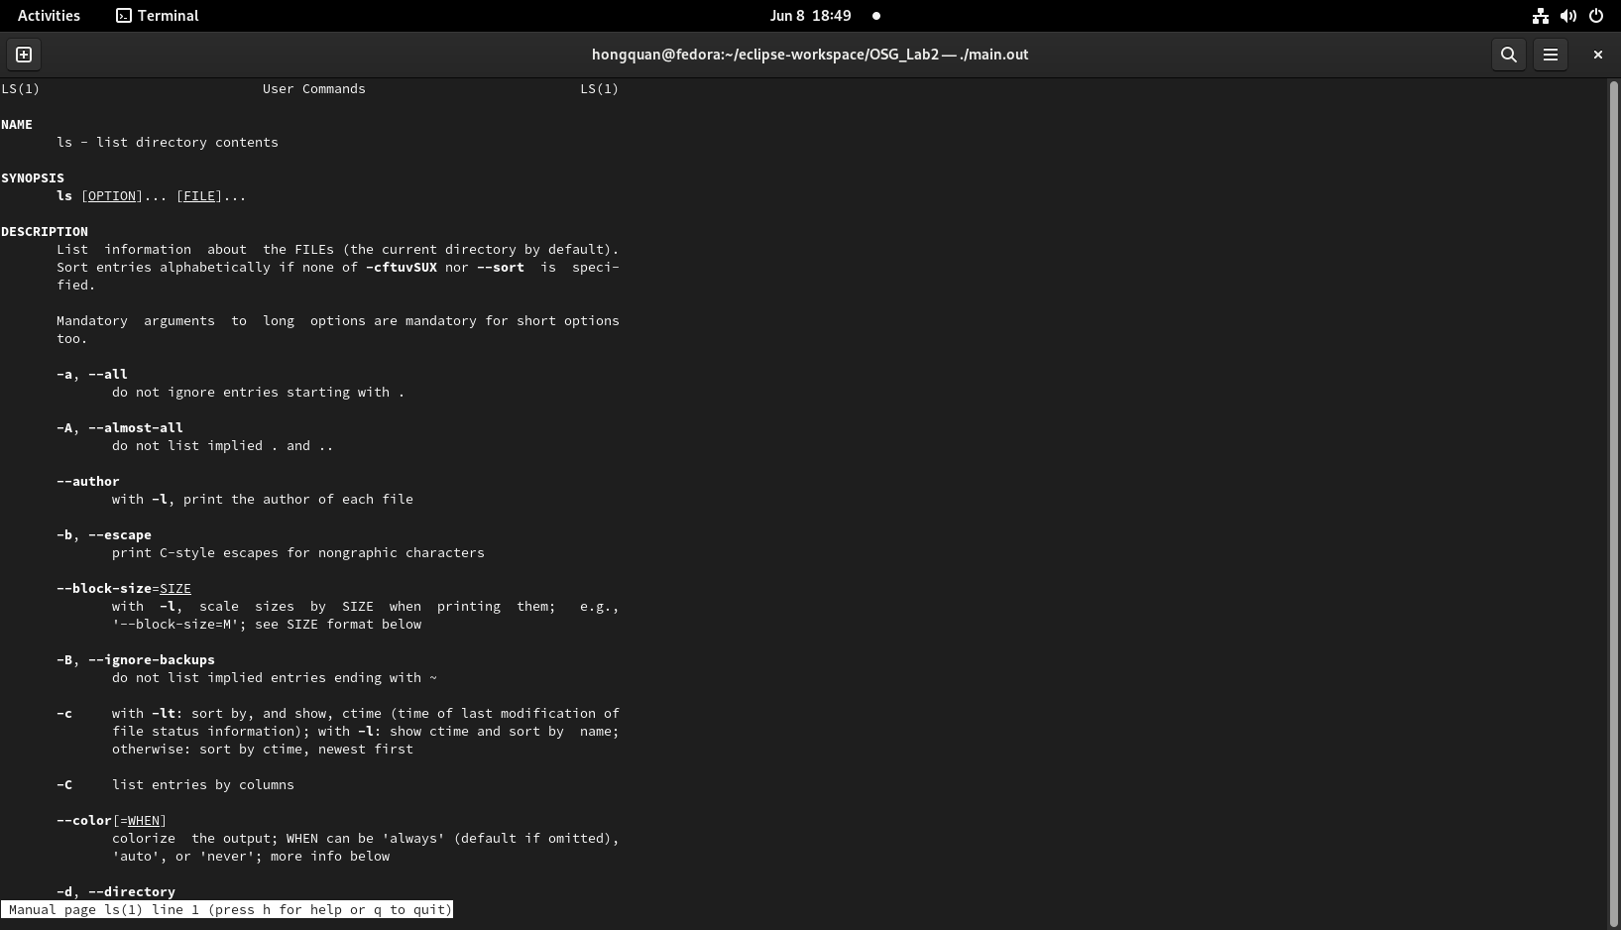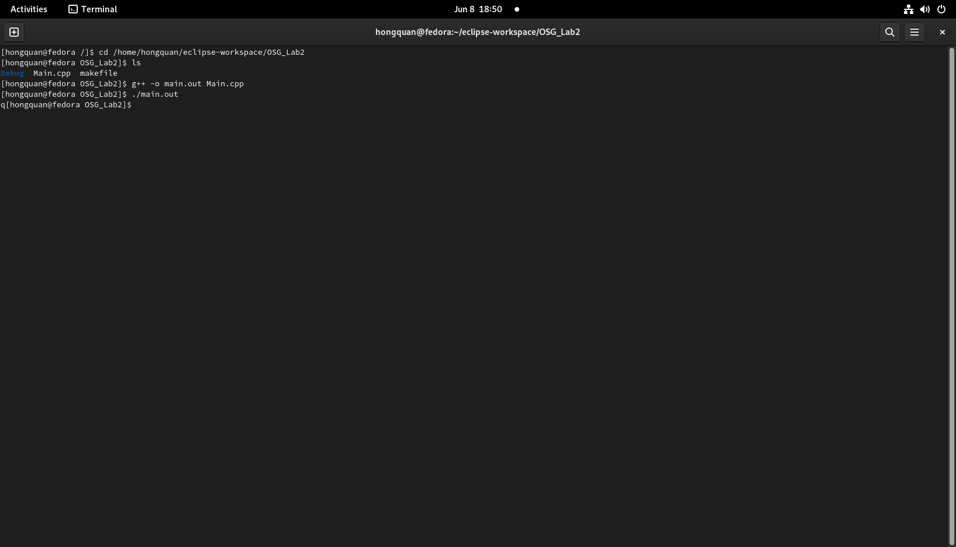

**Explain:**

The system() function in C is used to pass the commands that can be executed in the command processor or terminal of the operating system. Then, it executes the command and finally returns the status of the command, or -1 if there is an error.

In this case, we passed the man ls command in the system() function. Then, the computer executed the command and printed out the manual page of ls command in the output. After that, the system() function returned the status of the executed command, which was 0 for success. Next, the ret variable storred the return value of the system() function. Finally, the program returned the value of varabile ret , which was 0.